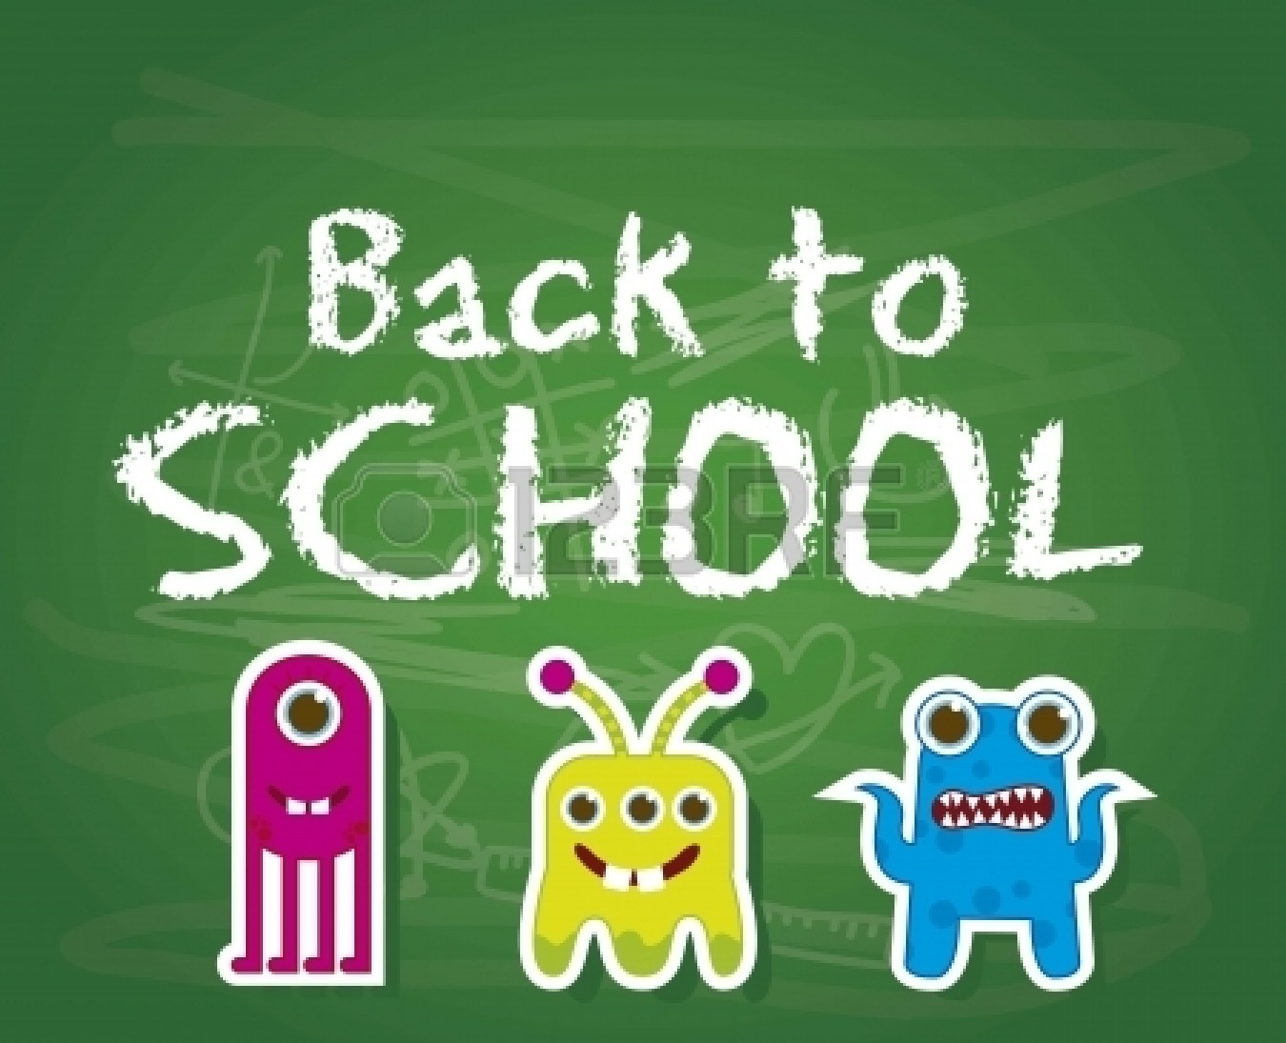

Parents, Guardians, and Preschoolers,
Welcome to the Bright Futures Preschool Program! I’ll be your teacher, Mrs. Ferrari with my marvelous assistant Mrs. Ellerbrock! I am extremely excited about starting my sixth year in Peru. Our year is going to be awesome! Our classroom has an amazing theme all about monsters! Don’t be scared, these monsters are very friendly and fuzzy too!
All about the Big Monster:
I am a graduate of Northern Illinois University where I studied Child Development. Once I graduated, I started my career as a preschool teacher for Head Start in Granville, IL. I then decided to further my studies and continue my education by receiving a Master’s degree in Early Childhood Education. After this, I received a job teaching preschool for Lincoln Elementary in Ottawa, IL. I left Ottawa for Peru where I fell in love with Peru’s outstanding school system. In December 2011, I finished my Masters in Administration. My background has created a wonderful foundation for teaching preschool.
I presently live in Spring Valley, where I was born and raised. I am married to Ray Ferrari Jr. and we have a beautiful family, a three year old boy named Carlo, a 21 month old girl named Cecelia and a six year old shitzu named Marley.
Some things I do along with teaching is, coach the Hall High School Devilettes. I am extremely busy but in my spare time I enjoy reading, and spending time with my friends and family.

Monster’s incorporated (Our class):
Our classroom theme this year is ‘Monsters’. The classroom is set up with adorable furry friends that your children will really enjoy. Our classroom hours are AM 8:30-11:00, PM 11:45-2:15PM. Attached you can find our class schedule and a little but about what we do.
The curriculum we use is the Creative Curriculum. This is an outstanding curriculum used to explore all areas of development; social, emotional, cognitive, physical, and language skills. The preschool handbook explains this curriculum more thoroughly. Our classroom is set up exemplifying this curriculum, it includes the following centers; reading, math, science, music, writing, listening, dramatic play, blocks, art, exploring, and gross motor.

Other Important Information for the adult Monsters:

Folders: 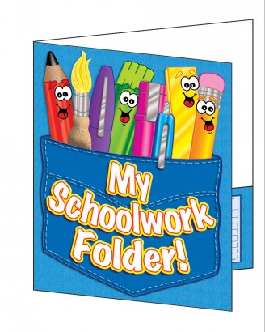

Your child will receive a two pocket folder, clearly labeled with their first and last name on it, as well as a number. This will be used to communicate notes back and forth on a daily bases. Within the folder will be a daily ‘monster’ behavior chart (explained below). Some days there may not be notes, but please check this daily. If you have any notes for me, put them in the folder and date them and I will respond as soon as possible. Any and all important paperwork has to be in the folder, I will not be going through bookbags. It is your child’s responsibility to get their folder out every day and place it in the appropriate numbered cubby.

Weekly Letters:
Each week I will be sending home letters that discuss our weekly themes. I will discuss the things your child will be learning, and also provide you with at home activities that correlate with the themes. I will also put the snack calendar, reminders, and important dates.

Snack Calendars:
At the end of each week you will receive a newsletter with a snack calendar on it. This will be located on the bottom left side. The name on the right side is the AM students; the left side is PM students. You will only have to provide snacks once a month, unless there is a special occasion. You are given the newsletter the week in advanced, therefore if you cannot provide snack for any reason please contact me ASAP. I will also send home reminder’s in your child’s folder the day before your snack day. If you should forget the snack, please send it ASAP to replenish our snack bin ☺ *Means this is your child’s Birthday please bring in Birthday treats! ** Means this is when we are celebrating your child’s Un-Birthday please bring Birthday Treats!

Snack Policy: 
As you may know we have a healthy snack policy. This means your snacks must be low sugar ‘healthy’ snacks. Please refer to the handbook for some suggested snacks. Each student will provide twenty pre-packaged snacks on their assigned day. Because of food allergies, homemade and snacks with peanut butter are prohibited. If you are sending items that require eating utensils, you will have to provide them for us. We only have napkins, and straws for snacks. Unfortunately, if your child brings anything that is not allowed we will have to send it back and request another snack. If you have any questions regarding this matter feel free to contact me.
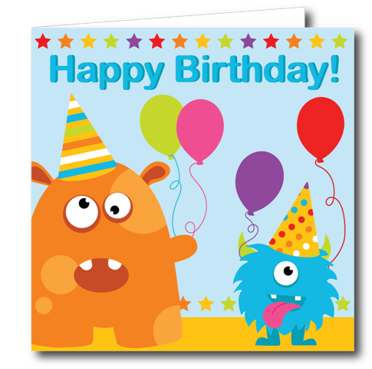** Please note: On your child’s birthday they will receive paper sunglasses, a pencil, and a sticker. We will sing happy birthday at snack time. We are not having a birthday party. An appropriate snack is store bought cookies or cupcakes (ingredients listed). ABSOLUTELY NO PEANUT BUTTER! Please do not send an entire cake, or one large cookie, there is not enough time to cut and disperse everything. Thank you!

Discipline Procedure: 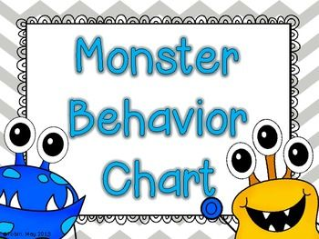
In my classroom I use positive words that will help redirect negative behaviors. I have a monster behavior chart, with colorful monster ‘levels’, and monsters on clothes pins. Each child’s name is on one of the clothes pins. The ‘levels’ consist of; Outstanding (purple), Great Day (pink), Good Job (blue), Ready to Learn (green), Think about it (yellow), Teacher Choice (orange), and Parent Contact (red). Each child starts on, Ready to Learn (green). If the child does something positive I will move their monster to ‘Good Job’ (blue). If two positive things happen, the monster is moved to ‘Great Day’ (pink). If three positive things happen, they move to ‘Outstanding’ (purple). If a child does something that necessitates a warning (taking toys, running, yelling, mean words, hurting others, etc.), the first time I will move their monster to ‘Think about it’ (yellow). Following the verbal warning will be a discussion with the child telling them specifically what they are doing that is inappropriate. If the behavior continues they are warned again, this time the monster moves to ‘Teacher Choice’ (orange). I will then give the child a choice to change their behavior. If the behavior continues for a third time the child’s monster must move to, Parent Contact (red), sit in time out for two minutes, and will receive a call home. After two minutes the child is talked to about what they did. If any violent acts take place it is an immediate time-out. The child will also receive a phone call home. Attached is a form that better explains our monster behavior chart. Each day I will send home a copy of what your child received that day. Generally your child will stay on ‘Ready to Learn’ (green).
If we see your child is having a difficult time with rules frequently we may ask you to come in for a visit after school to discuss the behaviors and get a plan in place for your child. If at any time you are seeing behaviors at home and need some information on a behavior management program to use in the home please feel free to contact me and I would be happy to help.

‘Monster’ous good BEEhavior: 
Following my discipline procedure above I am working on ways to promote positive behavior as well. Throughout the day I will be looking for good BEEhavior. When I see your child being; Responsible, Respectful, and Safe I will be rewarding them with stickers, and bee tickets.

All About me: 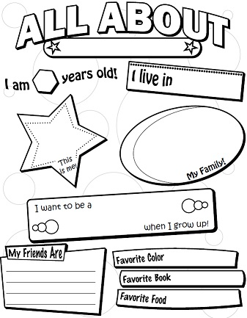
This year your child will be given a blank poster. Within this poster are headings for you to fill out with your child. You may answer the headings with pictures or words, depending on what you like. These posters will be given a couple of days before your child’s birthday. They are due on the day your child celebrates their birthday (refer to newsletter). They will be hung up in our classroom for everyone to enjoy.

Room Parents:
I will need one head room parent for each class, AM/PM. This parent will be chosen on a first come first serve bases. The head room parent will be responsible for planning parties, contacting other parents, and communicating with me. Room parents will be responsible for helping to plan and provide materials for special occasions. If you are interested in being a room parent or head room parent please fill out your choice on the questionnaire provided in this packet. Please fill it out and return ASAP. Thank you!

Scholastics book club: 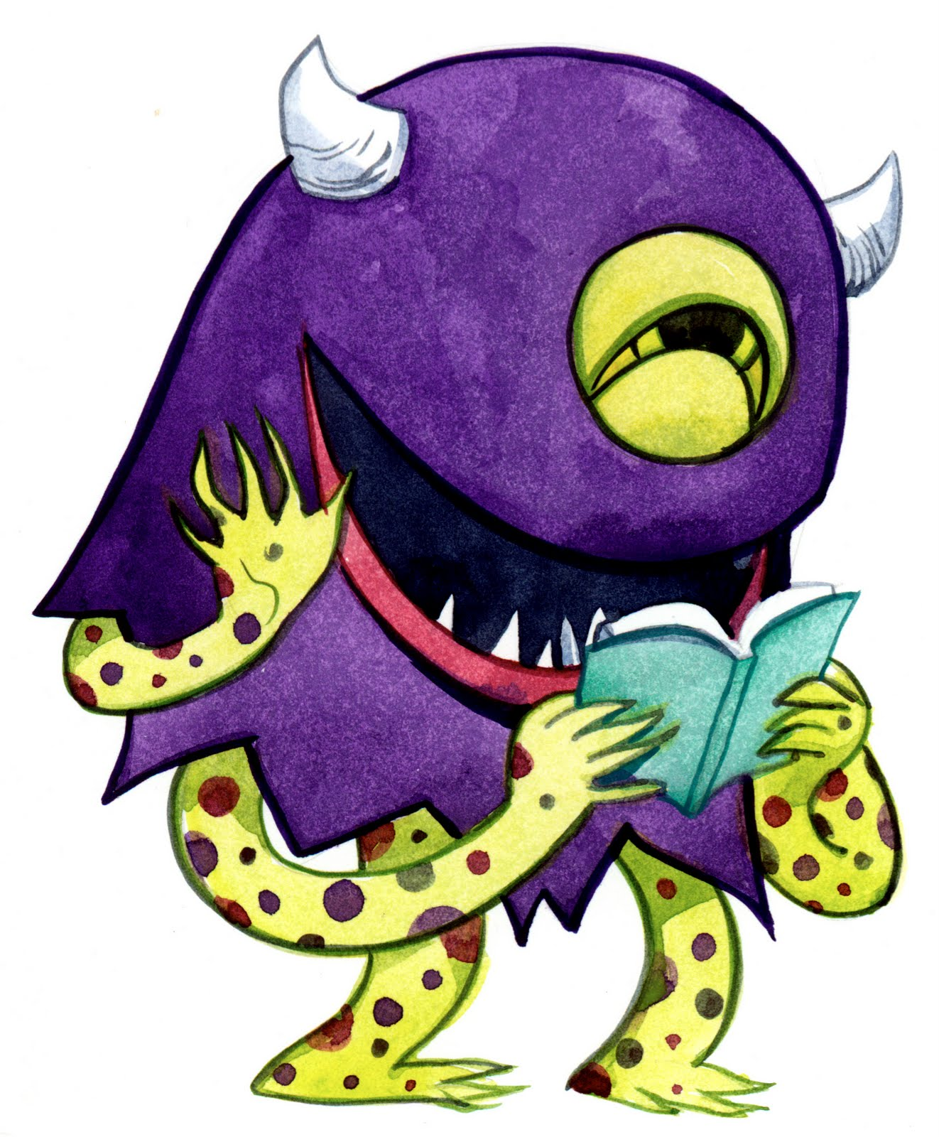
Scholastic magazines will go out the beginning of each month. Depending on the month, all orders and money will usually be due at the end of the month. I will take cash or check, please make checks out to Scholastic Book Clubs. The books will arrive approximately seven to ten days from the time the orders are placed. Each time you place an order the class will receive points, that can be redeemed for free purchases that will be utilized within your child’s classroom!!
Another convenient way to order is through the scholastics webpage. You just go to www.scholastics.com and look for the tab that says parents. The magazines that I send each month will be accessible on this website. You can order here, and pay with a credit or debit card. The username is linz3082 password is preschool. Each time you order online our classroom receives a free book! We really appreciate any orders you place, thank you very much!

Show and Tell: 
Every Friday we will be having Show and Tell. Your child may bring in one item from home that they would like to talk about. Sometimes I require certain items, but you will be notified if so! Also, note that children will not be allowed to play with these items throughout the day, they are strictly for Show and Tell. I do not want to be responsible for lost or stolen items! ABSOLUTELY NO ELECTRONIC ITEMS, WEAPONS, OR ANIMALS FOR SHOW AND TELL THANK YOU!

Mrs. Ferrari’s Webpage:
We do have a class website….www.perued.net, click on Northview School, Teacher pages, and then Mrs. Ferrari. Here you will find the thematic units, weekly letters, monthly calendars, a class schedule, web links, important reminders and some fun photos. If you need any extra forms you may print them out there. I will do my best to keep this updated for your benefit.

No More Monster Muck…
To conclude, I am extremely excited to start another school year! Please remember you are your child’s first and most important teacher! Feel free to come and visit anytime! I am thrilled to watch your child grow and learn in a developmentally appropriate environment. Also questions, comments, concerns can be addressed to lferrari@perued.net or call anytime @ (815) 223-2578. If you leave me a message I will do everything I can to respond ASAP.
Sincerely,
Mrs. Lindsay Ferrari
